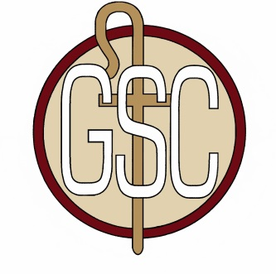
Good Shepherd Catholic Regional School

Grade 6—Stationery List

- 6 Hard Back Marble Copybooks
- 2 packs of wide ruled loose leaf
- Two Pocket Folders—5 or more
- Pencil Case
- Black or blue Pens
- Red Pens
- Pencils with erasers(Ticonderoga preferred)
- Highlighters
- Black Sharpie—1
- 1 pack dry erase markers
- Art Box with Snap-Tight lid (all art supplies should fit inside)
- Markers
- Colored Pencils
- Crayons
- Glue Stick
- Scissors
- Water colors

- 3 Boxes of Tissues
- 1 small bottle of hand sanitizer
- Roll of paper towels
- Clorox style wipes
- Contact paper (to cover ALL workbooks)
- 3 Book Socks are requested for textbooks.
- 1— 2 GB Flash drive Please label with student name
- 1—pair of headphones should be in the lab in a plastic bag
- Smock or old t-shirt for art
- Optional—mini stapler with staples, tote bag for changing of classes

